|  |
| --- |
| **A Project Report on**  (Online Placement Automation System )  Submitted for the partial fulfillment of the award of (Btech 3rd Year (Information Technology))     By  Disha Drishti(9042)  Richa Pandey(9086)  Shilpi Singh(9096)  Sumedha Singh(9116)  Udita Bose(9121)  To  Department of Computer Science, AIM&ACT  Under the supervision of  Mr. Manjeet Kumar (Internal)  Mr. Pradeep Sharma (External)    Banasthali Vidyapith  (2017) |

**(Organization Letter Head)**

**Certificate**

### Certified that Disha Drishti(9042), Richa Pandey(9086),Shilpi Singh(9096),Sumedha Singh(9116),Udita Bose(9121) has carried out the project work titled “Online Placement automation System” from _____(date) to ______ (date) for the award of the Btech 3rd Year Information Technology from Aim & Act department under my supervision. The thesis embodies result of original work and studies carried out by Student herself and the contents of the thesis do not form the basis for the award of any other degree to the candidate or to anybody else.

(Mr. Manjeet Kumar)

Designation: Assistant Professor

Place: Banasthali Vidyapith

Date:

**(Banasthali University Letter Head)**

### *CERTIFICATE*

### This is to certify that Disha Drishti(9042) a student of Btech 3rd Year, SixthSemester of Banasthali Vidyapith has completed the industrial project titled “Online Placement Automation System” in AIM & ACT Department of six months duration in partial fulfillment of Information Technology.

**Mr. Manjeet Kumar**

**(Banasthali University Letter Head)**

### *CERTIFICATE*

### This is to certify that Richa Pandey(9086) a student of Btech 3rd Year, SixthSemester of Banasthali Vidyapith has completed the industrial project titled “Online Placement Automation System” in AIM & ACT Department of six months duration in partial fulfillment of Information Technology.

**Mr. Manjeet Kumar**

**(Banasthali University Letter Head)**

### *CERTIFICATE*

### This is to certify that Shilpi Singh(9096) a student of Btech 3rd Year, SixthSemester of Banasthali Vidyapith has completed the industrial project titled “Online Placement Automation System” in AIM & ACT Department of six months duration in partial fulfillment of Information Technology.

**Mr. Manjeet Kumar**

**(Banasthali University Letter Head)**

### *CERTIFICATE*

### This is to certify that Sumedha Singh(9116) a student of Btech 3rd Year, SixthSemester of Banasthali Vidyapith has completed the industrial project titled “Online Placement Automation System” in AIM & ACT Department of six months duration in partial fulfillment of Information Technology.

**Mr. Manjeet Kumar**

**(Banasthali University Letter Head)**

### *CERTIFICATE*

### This is to certify that Udita Bose(9121) a student of Btech 3rd Year, SixthSemester of Banasthali Vidyapith has completed the industrial project titled “Online Placement Automation System” in AIM & ACT Department of six months duration in partial fulfillment of Information Technology.

**Mr. Manjeet Kumar**

**Abstract**

OPAS which stands for Online Placement Automated System for placements automates activities of placement cell through online by providing opportunities to the student community to use collective intelligence to increase selection ratio and eases out process of creation of management information automatically. OPAS focuses on the automation of the placement cell. It manages Placement process of each Job posting individually, authenticate and activate the student profiles created by the students only, send notifications to students, create list of students as per company HR Manager Job Request, provide the list of shortlisted student with resume, export data of shortlisted students to excel file based on Search Criteria, set preferences for student eligibility criteria for placement, secured Access to users, upload of cv format by the admin as per each company requirement, download of CV by the student, view news and events, update student information and their status with respect to placement, view reports of placements, calendar to be aware of date of arrival of the company, list of students that have registered for the company and various other events happening under Placement.

**Acknowledgement**

All of this would not have been possible without the unrelenting support and enthusiasm of our project guide-Mr. **Manjeet Kumar**. From suggesting us such a great topic for our project, and thereby educating and guiding us for the same, he has really been a shining light for all of us to pursue this endeavour. We would also like to thank **Prof. Pradeep Sharma**, Project Co-ordinator, for giving us the right instruction and helping us with all the technicalities of the documentation. We would also like to thank our Head of Department **Prof. C.K. Jha**, and our Principal **Mr. G.N. Purohit** for their support and encouragement. We would also like to thank the excellent faculty of the computer department, **AIM & ACT** for making our fundamentals clear, without which we would have never come this far.

**Disha Drishti (9042)**

**Richa Pandey (9086)**

**Shilpi Singh (9096)**

**Sumedha Singh (9116)**

**Udita Bose (9121)**

**Objective**

The objective of the project is to design software, which facilitates all functionalities for better management of placement and to guide the students. It also describes the design specifications of the system “**Online Placement Automation System**”. This document specifies all the flow control and logical flow of the system. So that one can easily understand how it does works. And its purpose is to specify the database of the system. It-

* Helps in fast access procedures in placement related activities.
* Easily finding out the list of eligible students for placements.
* Helps the students in their preparation for placement by providing previous years question papers of respective companies at one click.
* Save the time of both students and the placement officers.
* Helps in getting the details of placed students.
* It provides the session-wise records of placed students at the **Banasthali University** under the ***‘AIM & ACT’*** department.

**System Requirement Specification**

**1.Introduction**

System Requirement Specification is produced as cultivation of analysis task. Establishing a complete introduction, general information description, a functional final description and other information refine the function and performance allocated to software as a part of software engineering.

* 1. **Purpose**

The purpose of this software product is to design software, which facilitates all functionalities for better management of placement and to guide the students. It-

* Helps in fast access procedures in placement related activities.
* Easily finding out the list of eligible students for placements.
* Helps the students in their preparation for placement by providing previous years question papers of respective companies at one click.
* Save the time of both students and the placement officers.
* Helps in getting the details of placed students.
* It provides the session-wise records of placed students at the **Banasthali University** under the ***‘AIM & ACT’*** department.

**1.2-Scope**

The Placement Automation System is used to grade multiple-choice content examinations given to all incoming students in the college. Based on test results, the system makes recommendations for course placement and produces a number of different reports for various campus stakeholders. The system is designed to replace a manual system created and used manually by placement officers. The manual system has proved very valuable for its intended purpose but as an awkward user interface requires programming to make minor changes and relies on the academic mainframe computer. Therefore, to remove all the above mentioned drawbacks we design new software which has following features-

* Register
* Login/Logout
* Updating the student’s details
* Searching
* Deletion
* Verification of marks of students
* Provides all the information of various incoming companies during their placements at **Banasthali University** under the **‘AIM &ACT’** departmentof Computer **Science**.
* It contains precious suggestions for interview of our well-known experienced teachers of **‘AIM& ACT’** department.
* It contains session-wise placement records.

**1.3-Definitions, Acronyms & Abbreviations**

Following definitions, acronyms and abbreviations are used in the document-

|  |  |
| --- | --- |
| OPAS | Online Placement Automation System |
| Ada Admin | Administrator |
| HTTPS | Secure Hypertext Transfer Protocol is a HTTP over SSL(secure socket layer) |
| HTTP | Hypertext transfer protocol is a transaction oriented client/server protocol between web browser & a Web server |
| WWW | World Wide Web |
| TCP/IP | Transmission Control Protocol/Internet Protocol, the suite of communication protocols used to connect hosts on the Internet. TCP/IP uses several protocols, the two main ones being TCP and IP. |
| DB | Database is a collection of information that is organised so that it can easily be accessed, managed, and updated.  It is a collection of schemas, tables, queries, reports, views and other objects. MYSQL |
| Apache Tomcat 7.0 | It is an open-source web server and servlet container developed by the Apache Software Foundation (ASF). TOMCAT implements several Java EE specications including Java Servlet, Java Server Pages(JSP), Java EL, and Web Socket, and provides a “pure Java” HTTP web server environment for Java code to run in. |
| IEEE | Institute of Electrical and Electronics Engineers |
| OS | Operating System |
| DB | Database |
| HTML | Hypertext Mark-up Language |
| MYSQLNotifier (1.1.6) | Microsoft Structured Query Language |
|  |  |
|  |  |
|  |  |

**2.1 Product Perspective**

The OPAS is a networking based application which provides a group of workwith interface environment. This is self contained. We are trying to design an independent project in which all the modules are linked or interrelatedto one another and would run without the help of another project.

**2.1.1- Product Functions**

This site allows-

* Login by students and admin
* Search student details
* Search session-wise placements
* Update record
* Delete record
* Change password or password recovery
* Contain details of students
* Contain details about the companies
* Verification of student details
* Teachers suggestions
* Maintain session-wise placement records
* Records of highest paid students
* Logout

**2.2- User Characteristics**

Users of the website must possess a minimal educational level .Users of website must know how to navigate in a website.

* **REGISTERED CUSTOMER**

The user who is already registered will be considered as registered customer who can directly place order.

* **GUEST**

The user who just comes as guest and can only visit website but not allowed to place order before registering.

* **ADMIN**

These types of users are basically the administrator of whole website. They can change any data at any time without creating any conflict or any confusion for the rest of users.

**2.3- General Constraints**

1. **Higher Order Language Functions:** Java will be used for developing the web-pages with the help of NetBeans 8.0 and for the database information MYSQL Notifier (1.1.6) will be used.

1. **Criticality of the Application:** The server application will be available

24 X 7.

1. **Safety and Security Considerations:** The password and a valid username are the security issue.

**Specific Requirements**

**Functional Requirements**

We describe the functional requirements by giving various use cases-

**Student**

**Student**

**Admin**

***Note:-manage student details- search,delete,verify,update record***

**H/w and S/w Requirements**

**Hardware Requirements**

1. Server side requirement

* Processor: Pentium p4 (1-2 GHZ) or onwards.
* RAM: 1 GB or more.
* HDD: 20 GB (free space excluding data size).

2. Client side requirements

* Processor: Pentium p2 (1 GHZ) or onwards.
* RAM: 512 MB or more
* HDD: 8 GB or more.

3. Developer side requirements

* Processor: Pentium p4 (1-2 GHZ) or onwards.
* RAM: 2 GB or more.
* HDD: 40 GB or more

**Software Interface**

1. Server side requirements

* Operating system: Microsoft Windows Server 2000
* Web server: Apache Tomcat7.0

2. Client side requirements

* Operating system: Any operating system.
* Browser: Mozilla Firefox

3. Developer side requirement

* Operating system: Windows XP
* Browser: Any browser.
* Frontend: Framework: NetBeans Java Language
* Backend: MYSQLNotifier (1.1.6)
* Design Tools: NetBeans 8.0

|  |  |
| --- | --- |
| Use Case No | 1 |
| Use Case Name | Get registered |
| Actors: | Students |
| Description | This module helps the Students to create new accounts. |
| Input | Student name, login id, password. |
| Normal Course Events | 1. Student enters their e-mail address. 2. Student enters their passwords. 3. Student enters other required Information. 4. Student click sign up button. 5. System connects to database. 6. A message appears which shows the   membership applied.  Activation mail is sent. |
| Alternative Courses | 1. Same Login-id exists in database 2. Error message appears.   3. Continue with step 1 in the normal  course events.   1. An error may occur during the data   Base operation.  2. System shows error messages. |
| Output | New Student account will be created. |

**Use Case of get registered(Sign Up) Function**

**2.Sign In**

|  |  |
| --- | --- |
| Student Case No | 2 |
| Student Case Name | Sign in |
| Actors: | Registered Student and admin |
| Descriptions | This module helps the registered Student and  Admin to login. |
| Pre-conditions | The Student must be a member of the system. |
| Input | Login id and password. |
| Normal Course Events | 1. Student enters their login-id. 2. Student enters their password. 3. Student click login button. 4. System connects to database.   Homepage displayed. |
| Alternative Courses | 1. Student enters incorrect student name and d/or Password. 2. Error message appears. 3. Continue with step 1 in the normal   Course events.   1. An error may occur during the database   Operation.  System shows error messages. |
| Output | Student homepage will be displayed. |

**Use Case of Sign in Function**

**Sign Out**

**Non-Functional (Software System Attribute)**

* **Reliability**

The average time to failure shall be 30 days. In the event that a server does crash, a backup server will be up and running within the hour.

* **Availability**

The Online Automation site shall be available to users 24 hours a day, 7

days a week, with the exception of being down for maintenance no more

than one hour a week. If the system crashes, it should be back up within

one hour.

* **Security**

Students will be able to access only their own personal information and not that of other students. Student’s personal details will be handled through a secure server to ensure the protection of student’s personal information.

* **Maintainability**

Any updates or defect fixes shall be able to be made on server-side computers only without any patches required by the student.

* **Portability**

It is compatible on all Windows Operating System having MYSQL server

installed on server.

**System Design Specification**

**High- level design overview**

1 TIER

USER

INTERNET

2 TIER

3 TIER

Mysql Server

(Mysql Notifier 1.1.6)

Web server

(Apache Tomcat 7.0)

**we**

Login

Username:String

Password:String

Admin

Ad_id: String

Ad_name: String

Register()

View()

Modify()

Verify()

Input company detail

Student

Stud_id:String

F_name: String

M_name: String

L_name : String

Father_name:string

Mother_name:String

DOB

Contact: Number

T_address: String

P_address: String

State: String

City: String

Register()

Login()

Update_Profile()

View()

Company

C_id: String

C_name:String

Package:string

Contact:String

Course

Course_id:String

Course_name:String

Stud_course

Course_id:String

Stud_id:string

**Class Diagram**

Marks_UG

Stud_id: String

Course_id: String

Yr_of_10

Tot_marks_10: Number

Max_marks_10: Number

Yr_of_12

Tot_marks_10:Number

Max_marks_10:Number

Per12: Number

Sem1: Number

Sem2: Number

Sem3: Number

Sem4: Number

Sem5: Number

Sem6: Number

Marks_PG

Stud_id :String

Course_id:String

Yr_of_10

Tot_marks_10: Number

Max_marks_10: Number

Yr_of_12

Tot_marks_10: Number

Max_marks_10: Number

Per12: Number

Yr_of_UG

Per_UG: Number

Sem1: Number

Sem2: Number

Sem3: Number

Sem4: Number

**Database Design**

**Structure and Relationship**

**There are many different tables in this system:**

**Table 1:** Student Table

**Purpose:** This table is used for storing the login id and password

|  |  |  |  |  |
| --- | --- | --- | --- | --- |
| **Fields** | **Type** | **Size** | **Constraint** | **Description** |
| Stu_id | Varchar2 | 4 | Primary Key | Id of student |
| F_name | Varchar2 | 15 | NOTNULL | First name of student |
| M_name | Varchar2 | 15 | NOTNULL | Middle name of student |
| Father _name | Varchar2 | 50 | NOTNULL | Father’s name of student |
| T_address | Varchar2 | 100 | NOTNULL | Temporary address of student |
| P_address | Varchar2 | 100 | NOTNULL | Permanent address of student |
| Dob | Date |  | NOTNULL | Date of birth of student |
| Contact_no. | Number | 10 | NOTNULL | Contact number of student |
| City | Varchar2 | 20 | NOTNULL | City of student |
| State | Varchar2 | 20 | NOTNULL | State of the student |

**Table 2:** Login Table

**Purpose:** This table is used for storing the login id and password

|  |  |  |  |
| --- | --- | --- | --- |
| **Fields** | **Type** | **Size** | **Constraint** |
| user_id | Varchar2 | 4 | Foreign Key |
| password | Varchar2 | 30 | Not Null |
| Role | Varchar2 | 10 | Not Null/Check |
| question | Varchar2 | 10 | Not Null |
| answer | Varchar2 | 10 | Not Null |
| created By | Varchar2 | 50 | Not Null |
| created date | Date |  | Not Null |

**Table 3:** Course Table

**Purpose:** This table is used for storing the course of final year students

|  |  |  |  |
| --- | --- | --- | --- |
| **Fields** | **Type** | **Size** | **Constraints** |
| course_id | Varchar2 | 4 | Primary Key |
| course_name | Varchar2 | 20 | Not Null |
|  |  |  |  |

**Table 4:** Student _course

**Purpose:** This table is used for storing the course of the final year students.

|  |  |  |  |
| --- | --- | --- | --- |
| **Fields** | **Type** | **Size** | **Constraint** |
| stu_id | Varchar2 | 4 | Foreign Key |
| course_id | Varchar2 | 4 | Foreign Key |

**NOTE**: stu_id and course_id is composite primary key

**Table 5:**  Admin Table

**Purpose:** This table is used for storing the Information by the admin.

|  |  |  |  |
| --- | --- | --- | --- |
| **Fields** | **Type** | **Size** | **Constraint** |
| user_name | Varchar2 | 20 | Not Null |
| user_id | Varchar2 | 4 | Primary Key |
| Email | Varchar2 | 20 | Not Null |
| mob_no. | Number | 10 | Not Null |

**Table 6:** Stud_placed_comp

**Purpose:** This table is used to store the information of students who has got placed in various companies.

|  |  |  |  |
| --- | --- | --- | --- |
| **Fields** | **Type** | **Size** | **Constraint** |
| stu_id | Varchar2 | 4 | Foreign Key |
| comp_id | Varchar2 | 4 | Foreign Key |

**NOTE:** stu_id and comp_id is a composite primary key

**Table 7:** Company Table

**Purpose:** This table is used to store the information about the various companies.

|  |  |  |  |
| --- | --- | --- | --- |
| **Fields** | **Type** | **Size** | **Constraint** |
| c_id | Varchar2 | 4 | Primary Key |
| c_name | Varchar2 | 20 | Not Null |
| c_add | Varchar2 | 100 | Check |
| contact_no. | Number | 10 | Not Null |
| Pakage | Currency | 5 | Not Null |
|  |  |  |  |

**Table 8:** Under-Graduation table

**Purpose:** This table is used for storing the marks of under- graduation students.

|  |  |  |  |
| --- | --- | --- | --- |
| **Fields** | **Type** | **Size** | **Constraint** |
| Stu_id | Varchar2 | 4 | foreign Key |
| Course_id | Varchar2 | 4 | foreign Key |
| Year_of_10th | Date |  | Not Null |
| Tot_marks_10 | Number | 3 | Not Null |
| Max_marks_10 | Number | 3 | Not Null |
| Per_10 | Number | 3 | Not Null |
| Year_of_12 | Date |  | Not Null |
| Tot_marks_12 | Number | 3 | Not Null |
| Max_marks_12 | Number | 3 | Not Null |
| Per_12 | Number | 3 | Not Null |
| Sem1 | Number | 3 | Not Null |
| Sem2 | Number | 3 | Not Null |
| Sem3 | Number | 3 | Not Null |
| Sem4 | Number | 3 | Not Null |
| Sem5 | Number | 3 |  |
| Sem6 | Number | 3 |  |
|  |  |  |  |

**Note:** stud_id and course_id is a primary key

**Table 9:**Post-Graduation Table

**Purpose:** This table is used for storing the marks of post- graduation students.

|  |  |  |  |
| --- | --- | --- | --- |
| **Fields** | **Type** | **Size** | **Constraint** |
| Stu_id | Varchar2 | 4 | Foreign Key |
| Course_id | Varchar2 | 4 | Foreign Key |
| 10th_year | Date |  | Not Null |
| Per_10 | Number | 3 | Not Null |
| 12th_year | Date |  | Not Null |
| Per_12 | Number | 3 | Not Null |
| UG_year | Date |  | Not Null |
| Per_UG | Number | 3 | Not Null |
| Sem1 | Number | 3 | Not Null |
| Sem2 | Number | 3 | Not Null |
| Sem3 | Number | 3 | Not Null |
| Sem4 | Number | 3 | Not Null |

**Activity Diagram of Detailed description of components**

**Activity diagram for Admin**

Enter User id and password

NO

Verified

YES

Login

submit

Verify required information

Fill required fields

View information

**Activity diagram for Students**

ENTER USER_ID AND PASSWORD

NO

Verified

YES

Login

Submit

Fill Form

View Information

**Sequence Diagram**

**For Admin**

**ADMIN**

**DATABASE**

**OPAS**

LOGIN

VALIDATE

REGISTER, VIEW, MODIFY, VERIFY ON SUCCESS

UPDATE,ENTER COMP. DETAILS

STORE

LOGGED OUT

ON FAILURE

LOGIN PAGE

**For Student**

**DATABASE**

**STUDENT**

**OPAS**

LOGIN

VALIDATE

ON SUCCESS

REGISTER,UPDATE DETAILS, VIEW

STORE

LOGGED OUT

ON FAILURE

LOGIN PAGE

**User Interface**

**1) First Page**



**2) Registration Page**

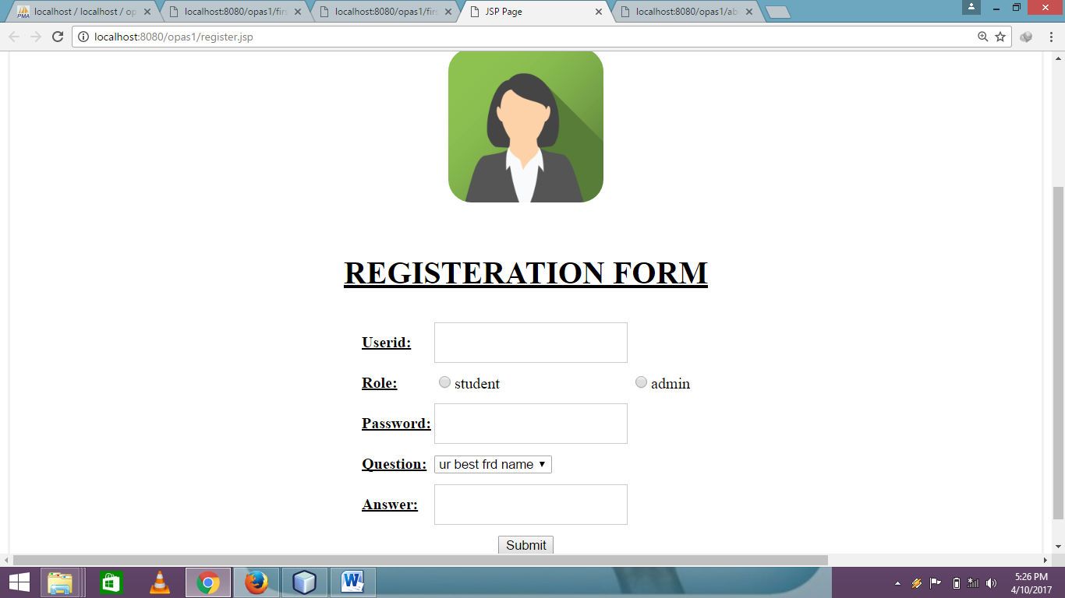

**3) Login Page**

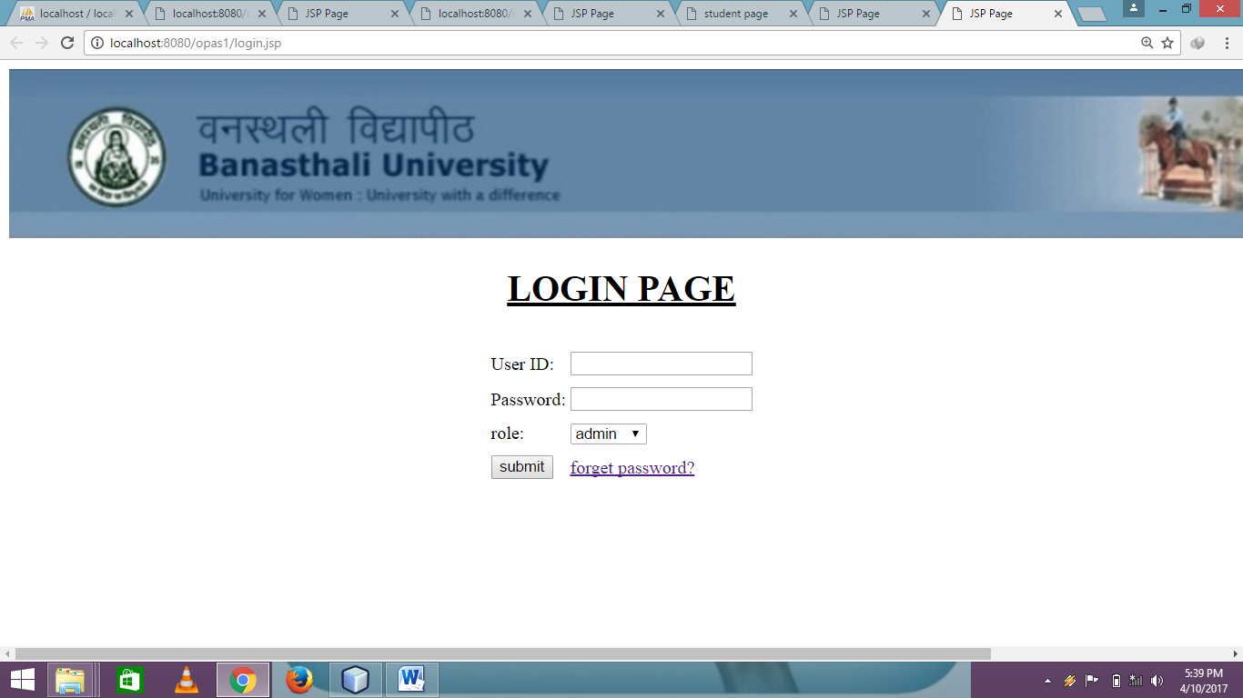

**4) Under Graduation Page**

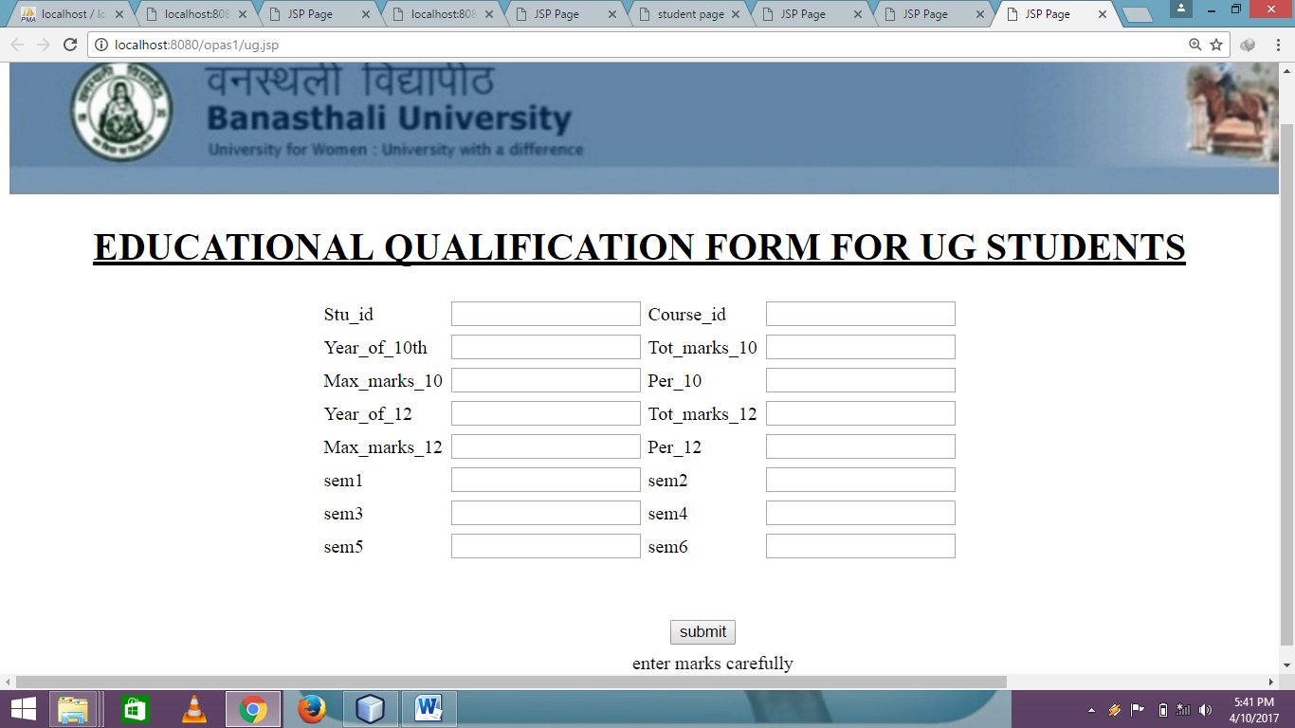

**5) Role Student Page**

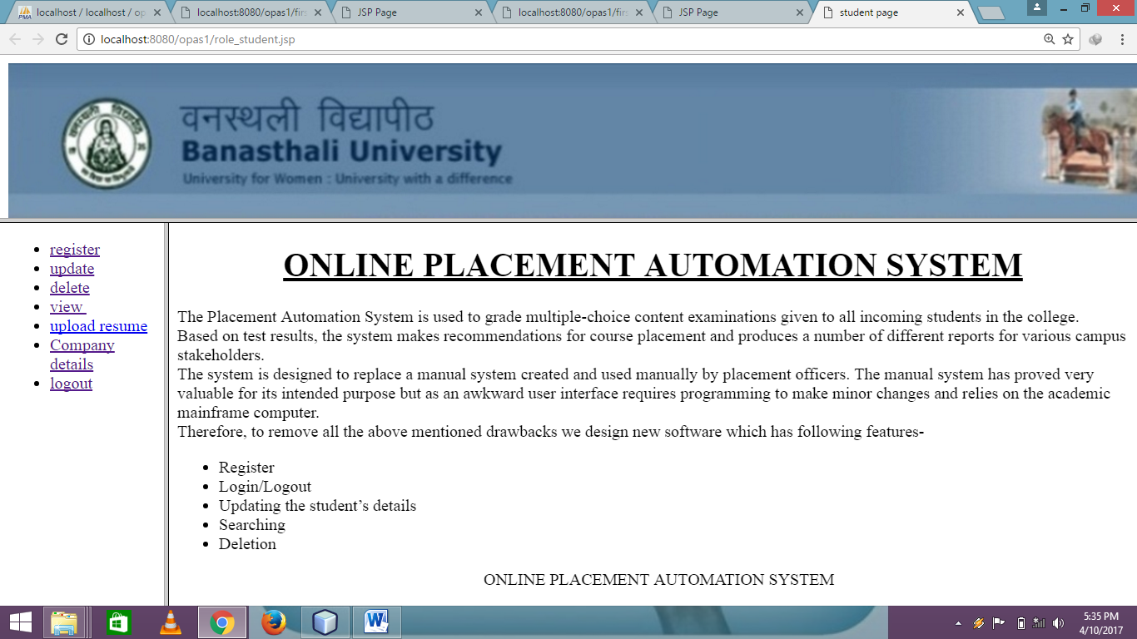

**6) Online Registration Page**

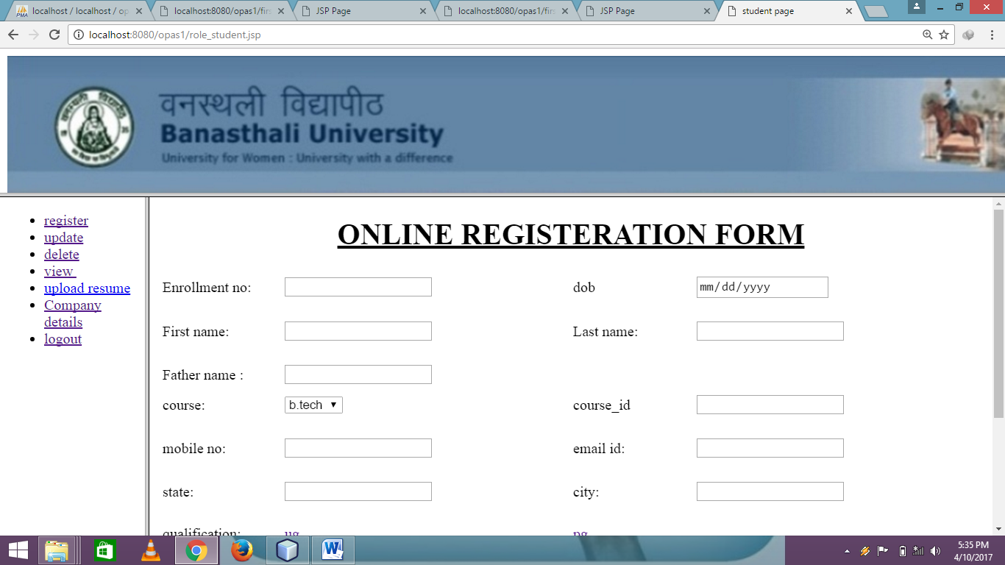

**7) Update Entries Page**

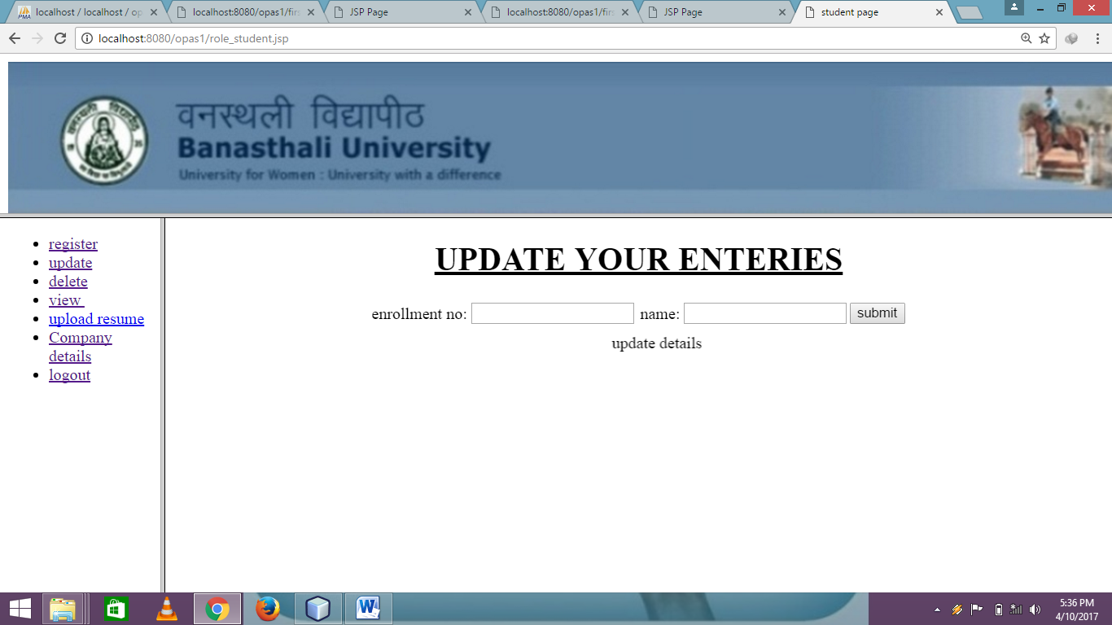

**8) Delete Record Page**

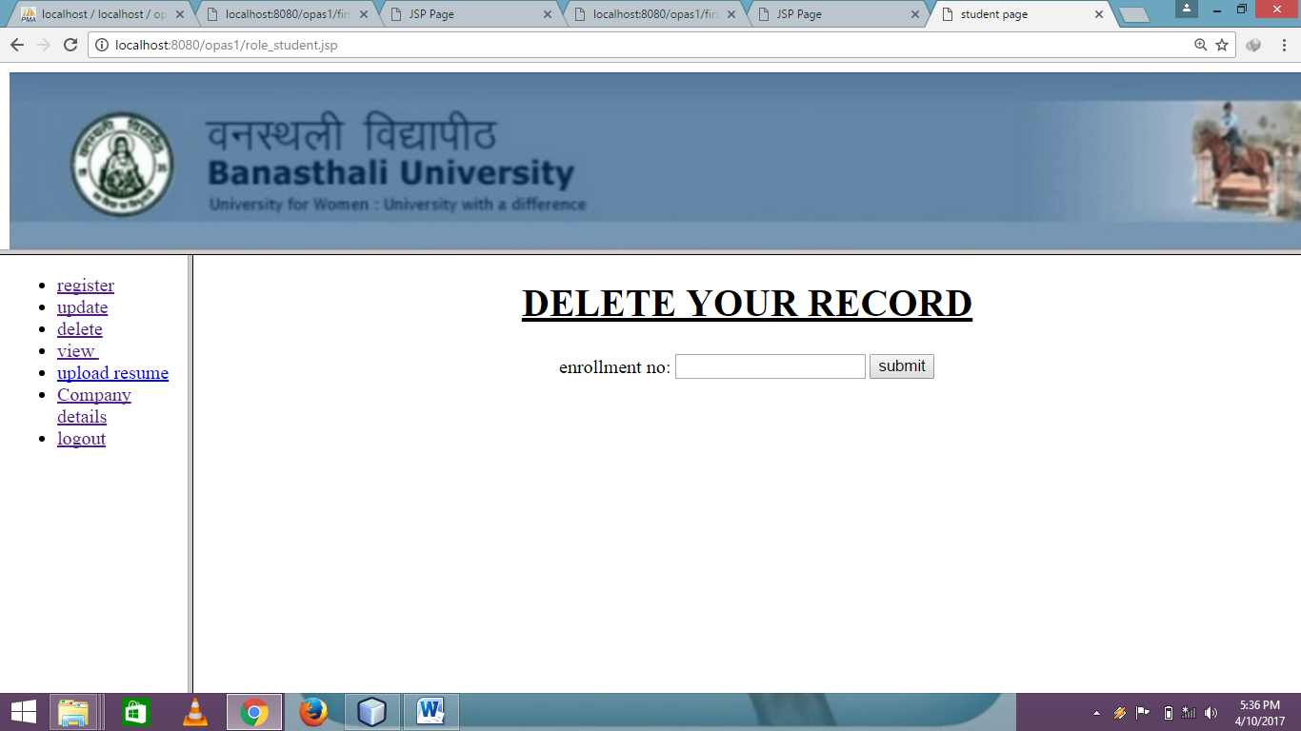

**9) View Details Page**

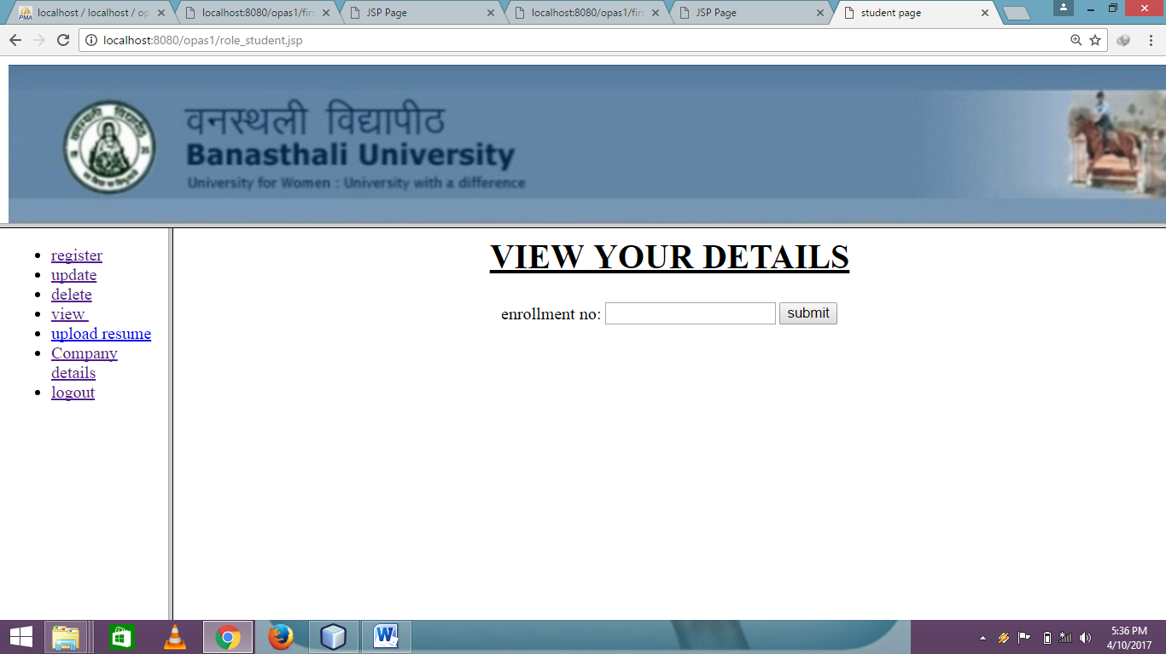

**10) Company Details Page**

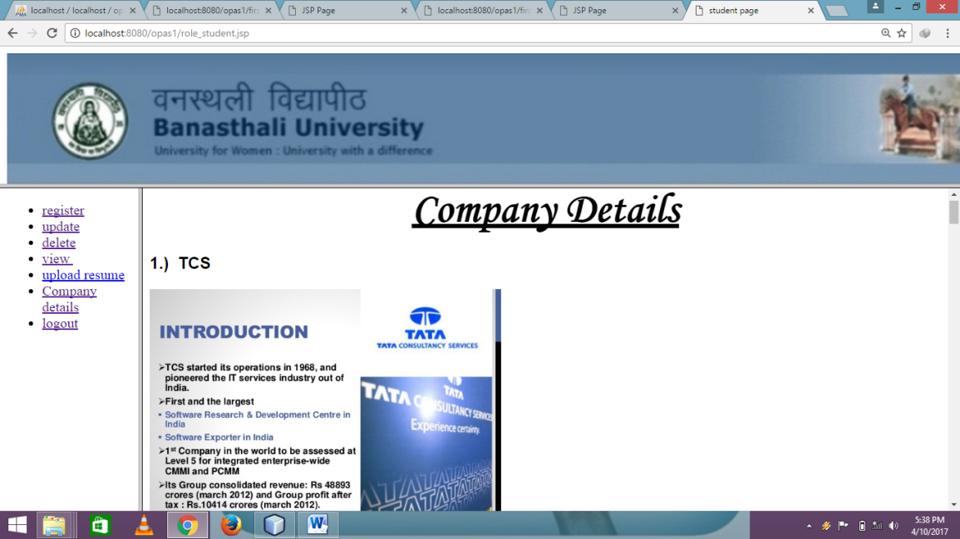

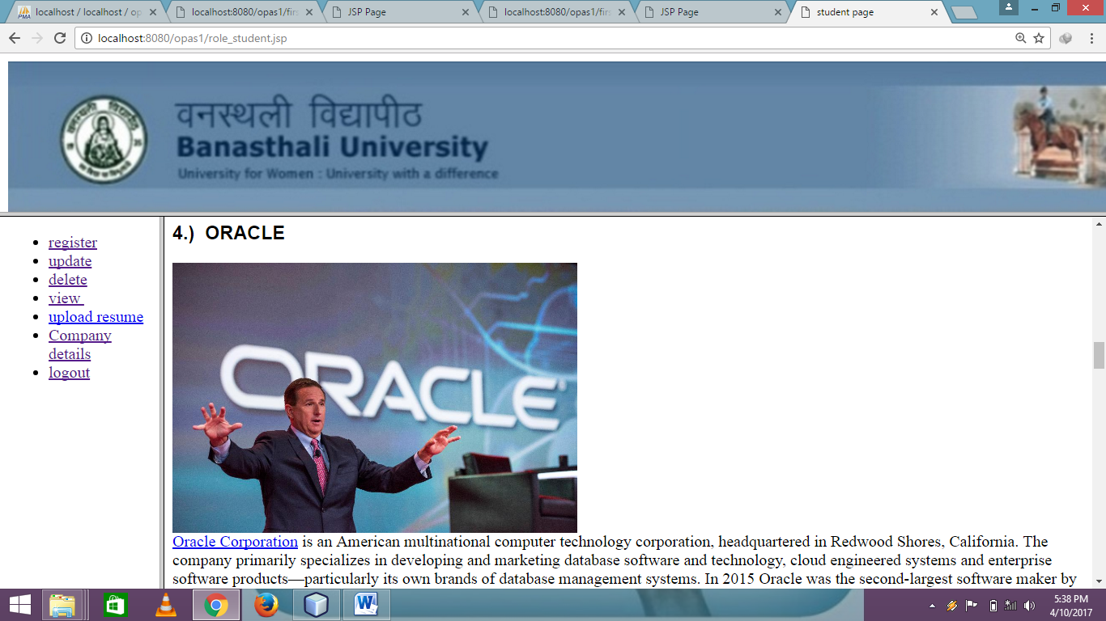

**References**

* IEEE Standard 830-1993, IEEE recommended Practice for Software Requirement Specifications
* Herbert Scheldt, **Java: The Complete Reference J2SE,** 5th Edition, Tata McGraw Hill
* E. Balaguruswamy ,**Programming with Java** , Tata McGraw-Hill Publications
* Ivan Bayross, **Web Enabled Commercial application development using HTML,DHTML, JavaScript**
* **W3schools**
* **Tutorialspoint.com**
* Ariponnammal S. and Natarajan S. (1994) ‘ Transport Phenomena of Sm Se 1-x Asx’ Pramana-Journal of Physics Vol. 42 No. 5pp. 421-425
* Barnard R.W. and Kellogg C. (1980) ‘Applications of Convolution operators to problems in univalent function theory. Michigan Mach. J., Vol 27, pp 81-94.
* Jankins G.M. and Walts D.G. (1968), Spectral Analysis and its Applications’ Holder Day, Sanfrancisco.
* Shin K.G.and Mckay N.D. (1984) ‘Open loop minimum time control of mechanical manipulations and its applications’, Proc. Amer Contr. Conf., San Diego, CA, pp. 1231-1236.